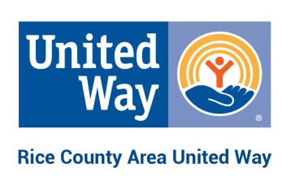
Board of Directors Application
Personal Information:
Name: _______________________________________________________________________________
Address: _____________________________________________________________________________
Home phone: _______________ Cell phone: ___________________ Work phone: _________________
Email: _______________________________________________________________________________

- Why are you interested in serving on the Board of Directors for Rice County Area United Way?

- Please explain your experience with the United Way, including any prior experience with the former United Way of Faribault or Northfield Area United Way.

- The Rice County Area United Way Board of Directors provides operational oversight and organizational governance. Given the functions of the board, please describe your qualifications for this position.

- Please list community, civic, or public service activities in which you have participated as a member, an officer, or a resource person.

- Please answer the following questions or submit a resume:
  - Please describe your educational background.

  - Please describe your occupational history including position held, employer, and length of service.

