Hello, Reading Enthusiasts!
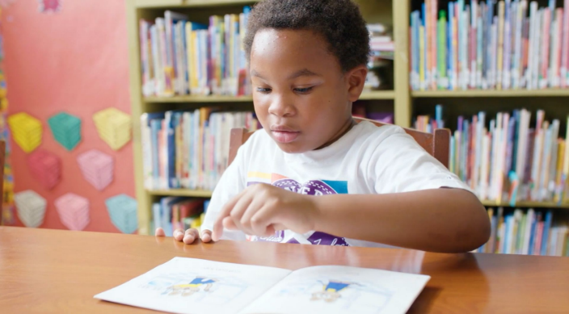
In Rice County, too many children are failing to read at their grade level. In 2021, less than 42% of children in Rice County were reading at their grade level by the end of third grade – and statistics show, one in four of those children won’t graduate from high school.
Fortunately, through Rice County Area United Way, we have Dolly Parton’s Imagination Library sending books home monthly before kindergarten. But we need help to keep this program going. Children who have been enrolled in Imagination Library:
- Are more likely to be ready for kindergarten
- Are more likely to read at their grade level in elementary school
We want EVERY child in the Rice County area to have this important tool to engage them in reading before kindergarten. Last year Dolly Parton’s Imagination Library sent home 18,360 books locally and now there are more than 1500 local children enrolled!
Teachers and parents are enthusiastic about the program, and don’t want to see it go away. To keep the program going, we need to raise $30,000 – and with more funds, even more children can be signed up! It only costs $30/child for enrollment in Imagination Library for one year and is always FREE to the children’s families. How many children could you inspire to read?
[Your organization] Goal = Sponsor XXX children in Imagination Library.
$600 sponsors 4 children from birth to kindergarten
$300 sponsors 2 children from birth to kindergarten
$150 sponsors a child from birth to kindergarten
$60 sponsors 2 children for one year
$30 sponsors 1 child for one year
Please join this effort with a sponsorship at any level. All sponsors will be thanked as part of Dolly Parton’s Birthday Bash – so save the date of January 19 and celebrate at the Northfield Armory!

